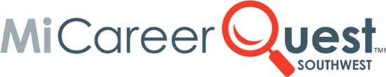
Field Trip Permission Form

Dear Parent/Guardian:

MiCareerQuest-Southwest is a unique hands‐on experience, where students will find out what it is really like to be an RN, a graphic artist, a mechanical engineer and more. Students will interact
with business and industry and post-secondary partners in these areas: Information Technology and Business, Health and Human Services, Engineering & Manufacturing, and Professional Trades. To view the impact from our event, visit http://www.micareerquestsw.org. MiCareerQuest-SW will expose students to exciting careers and get them inspired about their futures!
This career education event sponsored by Kalamazoo RESA will take place on May 17-18 for 8th graders. Students will attend one of these days and be transported by school bus to the Kalamazoo Expo Center.
Please complete, sign and return the bottom statement of consent and release of liability

NO LATER THAN:

Notice of Non-discrimination: It is the policy of Kalamazoo Regional Educational Service Agency that no discriminating practices based on race, color, national origin, sex (including sexual orientation or sexual identity), disability, age, religion, height, weight, marital or family status, military status, ancestry, genetic information or any other legally protected category be allowed during any program, activity, service or in employment. The following positions at Kalamazoo RESA have been designated to handle inquiries regarding the nondiscrimination policy: Assistant Superintendents - Tom Zahrt, Mindy Miller & Dr. Jennifer Sell. Contact information: 269-250-9200, 1819 E. Milham Ave, Portage, MI 49002.

- - - - - - - - - - - - - - - - - - - - - - - - - - - - - - - - - - - - - - - - - - - - - - - - - - - - - - - - - - - - - - - - - - - - - - - - - - - - - -
PARENT/GUARDIAN CONSENT FORM
Student Name: School:
I consent to my child participating in the described field trip. I also consent to a staff member contacting medical help for my child, at my expense, should illness or accident occur during the time away from school. I understand that, as parent/guardian, I remain fully responsible for any legal responsibility, which may result from any personal actions taken by the above named student.
Name of Parent/Guardian:
(Please Print)
Signature of Parent/Guardian: Date:
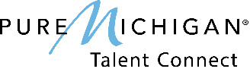
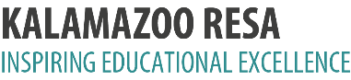
Sponsored by:
Education for Employment, Education for the Arts, Early/Middle College and Youth Opportunities Unlimited

